Robert R. Shaw Center for S.T.E.A.M.
Katy ISD, Katy, Texas
Basic Safety Training Qualification Test

Name: _____________________________ Date: ____________________

Team: _____________________________ School: __________________

1. On the floor plan below, indicate the locations for the following by letter:
A. Emergency exits
B. Fire extinguishers
C. AED
Floor Plan

2. What PPE and clothing are required in all shop work areas of the RSC?
A. Safety glasses and steel-toed boots
B. Safety glasses with side shields and substantial shoes
C. No specific PPE are required
D. Normal glasses, earplugs, gloves, fire-resistant clothing

3. Open flames are allowed in the RSC. True or False?

4. Loose clothing, jewelry, and long hair are permissible in the RSC without restrictions. True or False?

5. Teams are not required to train their members or maintain any records of training; just make sure everyone works safely. True or False?

6. Which of the following are allowed in the RSC?
A. Food and drinks in all areas
B. Careful use of volatile materials and spray paint
C. Water
D. Horseplay
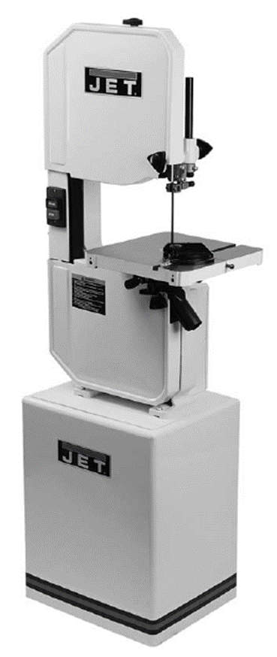
7. Label the following parts of the band saw with the indicated letter on the band saw illustration at right.
A. Blade
B. Table
C. Upper blade guide
D. On/off switch
E. Base
F. Lower wheel guard

8. Which of the following is NOT a requirement when using the band saw?
A. Gloves and hearing protection
B. Safety glasses with side shields
C. Keeping doors and guards in place
D. Adjusting the upper blade guide before cutting

9. When making a cut on the band saw, it is OK to remove cuttings and the work piece without stopping the saw blade.
True or False?

10. The band saw blade is making a banging sound as it cuts. What is probably wrong?
A. The blade is out of adjustment
B. There is nothing wrong; it just does that sometimes
C. The belts are loose
D. The blade gullets are full of chips

11. You have a minor injury that requires first aid. What do you need to do?
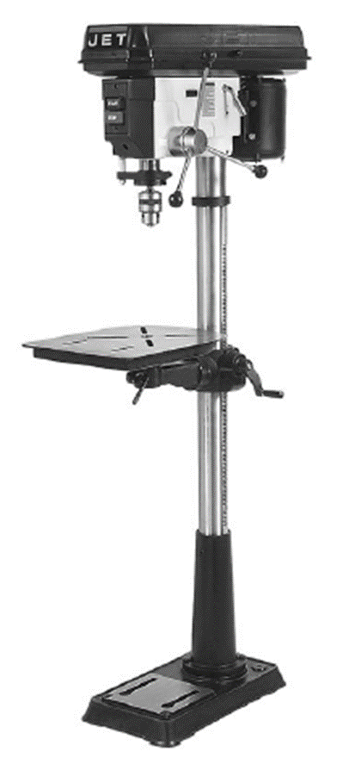
A. Just use the first aid kit and put a band aid on it
B. Call 911
C. Report it to your mentor and the RSC Administrator
D. Keep quiet about it

12. Your team is required to do annual refresher safety training on the RSC safety rules and tools. True or False?

13. Visitors to the team bays and field are NOT required to be screened or comply with any of the safety rules. True or False?

14. Label the following parts of the drill press using the indicated letter on the drill press illustration at right..
A. Drive belts and pulleys
B. Drill chuck
C. table
D. Table height crank handle
E. Base
F. Column
G. Downfeed handle
H. On/off switch

15. When drilling a hole with the drill press, which of the following should you NOT do?
A. Hold the work piece directly on the table and drill all the way through to be sure you have a good hole
B. Secure the work piece to the table with a spacer underneath
C. Tighten the drill bit in the chuck
D. Pre-punch the location of the hole to prevent bit from wandering

